Dr. Mathew Ullom, B.S., D.C.
Dr. Aaron Koepp, D.C., DABCO

PERSONAL INFORMATION

Name ________________________________ What do you prefer to be called? __________________Date___________
Address_____________________________________ City__________________________ State_____ Zip_____________
Email address ________________________________________________________________________________________
Home Phone #______________________ Cell Phone #_____________________ Work Phone # ____________________ Social Security Number___________________ DL # ____________State____ Student? _____ (___Full ___ Part time)
Date of Birth _________ Age_____Type of Work_____________________ Employer ___________________________
Check One: Married____ Single____ Name of Spouse_____________________ Contact Phone ____________________
In case of emergency contact: Name___________________________________ Contact Phone ____________________
Who is your personal physician/PCP?__________________________________ Contact Phone_____________________
May we send correspondence to your personal physician? Yes____ No_____

Whom may we thank for referring you to our office?_____________________________________

CURRENT HEALTH CONDITION/PROBLEM

Please complete this form entirely. This will enable the Doctor to better understand your condition.

Please mark the location of your pain/problem below. Please describe your condition. Include what your
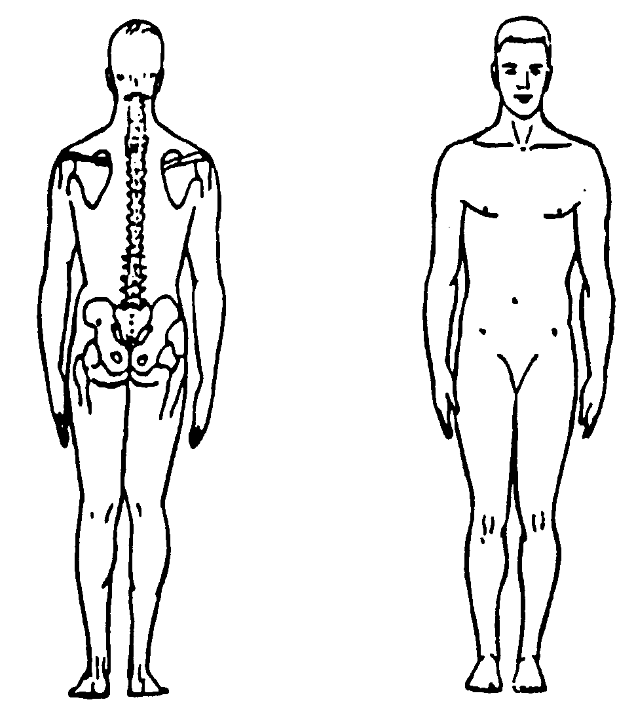
symptoms feel like and how often they bother you
(i.e. dull, tight, daily, etc.).
_______________________________________
_______________________________________
_______________________________________
_______________________________________
_______________________________________
_______________________________________
_______________________________________
_______________________________________

Please check any symptoms or qualities that apply in your condition:

___Headaches ___Dizziness ___Sensitivity to Light ___Diarrhea
___Neck Pain ___Heavy Head ___Loss of Memory ___Cold Feet
___Stiff Neck ___Pins & Needles in Arms ___Ears Ringing ___Cold Hands
___Problems Sleeping ___Pins & Needles in Legs ___Face Flushed ___Upset Stomach
___Back Pain ___Numbness in Fingers ___Buzzing in Ears ___Constipation
___Nervousness ___Numbness in Toes ___Loss of Balance ___Cold Sweats
___Tension ___Shortness of Breath ___Fainting Spells ___Fever
___Irritability ___Low Energy ___Loss of Taste ___Jaw Pain
___Chest Pain ___Depression ___Loss of Smell ___Jaw Clicking/Popping
- When was the first time you were aware of this problem/episode?__________________________________________ ______________________________________________________________________________________________
- How did this condition start? What caused it?__________________________________________________________
______________________________________________________________________________________________
- Have you ever had this problem or a similar problem before? If YES, please explain.__________________________
______________________________________________________________________________________________
- Do you have any pain/numbness/tingling/weakness in your arms or legs?______________________________________
- When your symptoms are at their WORST, please rate the SEVERITY (1 being minimal, 10 being extreme):
1 2 3 4 5 6 7 8 9 10
- What aggravates your condition? (Activities, Positions, Movements, Other)__________________________________
______________________________________________________________________________________________
- What improves your condition? (Ice, Heat, Sitting, Standing, Rest, Medication, Other) _________________________
______________________________________________________________________________________________
- Does your condition vary depending on the time of day? If YES, please explain. _____________________________
______________________________________________________________________________________________
- Overall, has your condition been getting better, worse or staying the same? __________________________________
- How has this condition interfered with or affected your:
Daily Activities?______ ________________________________________________________________________
Work Duties?________________________________________________________________________________
Recreational Activities? ________________________________________________________________________
Sleep Patterns? ______________________________________________________________________________
- Are you pregnant? _____ YES ______ NO
- Please list any prescription medications, over-the-counter remedies or nutritional supplements that you are currently taking:_________________________________________________________________________________________
______________________________________________________________________________________________
- Have you received ANY TREATMENT for this condition? Yes _____ No _____
If YES, please describe when, what treatment was rendered and what the results were:_________________________
______________________________________________________________________________________________
- Have you EVER consulted a Chiropractor in the past? Yes _____ No _____
Name:__________________________________ Dates consulted: ________________________________
For what problem: _______________________________________________________________________________

People choose chiropractic care for a number of reasons. How long you decide to benefit from chiropractic care is always up to you. Please check the type of care you desire so that we can meet your needs whenever possible.

_____ Temporary Relief _____ Lasting Correction _____ Check here if you would like the Dr. to decide the best type of care for you.

By my signature below, I authorize ChiroCare of Fort Collins, P.C./Rocky Mountain Chiro Care, P.C. to request or discuss any pertinent records, or to release any information deemed appropriate to any doctor, insurance company or attorney in the course of my treatment or in order to process any claim for reimbursement of charges. I hereby assign all right, title and interest relative to insurance benefits to ChiroCare of Fort Collins, P.C./Rocky Mountain ChiroCare, P.C. I clearly understand and agree that I am personally responsible for payment of all services rendered to me. Further, in the event that my account is turned over for collection, I understand that I will be responsible for any interest charges, attorney fees, collection costs and court costs incurred in collecting the balance.
By my signature below, I acknowledge that there are inherent risks involved with spinal manipulation. In 1995, Rand reported that risk of serious complication approximate 1 in 1 Million to 1 in 1.5 Million. I authorize the doctor to diagnose and treat my condition as deemed appropriate, including the use of spinal manipulation. I understand the above information and guarantee that this form was completed correctly to the best of my knowledge. I also give ChiroCare of Fort Collins, P.C./Rocky Mountain Chiro Care, P.C. and their representatives permission to communicate to me via the contact information above.

Signature:____________________________________________________ Date:____________________
If Minor, Parent or Guardian Signature:____________________________ Date:____________________

Revised 06.2012

